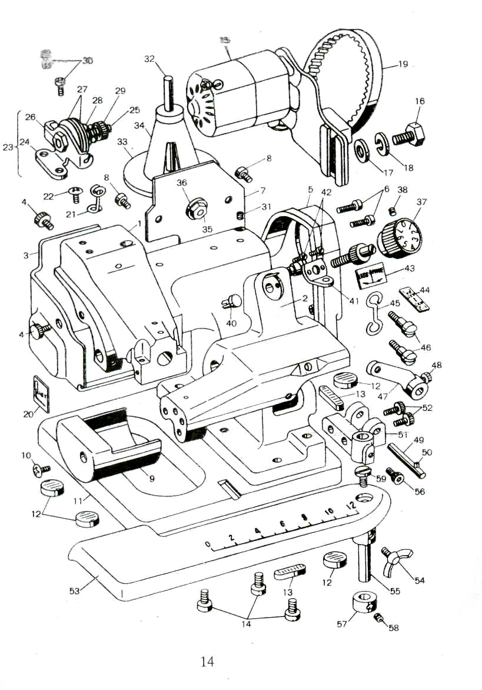

Ref.No. | Part.No. | Description
1 | 8101 | Machine frame
2 | 8102 | Cylinder bed
3 | 8103 | Arm side cover
4 | 80116 | Arm side cover clamp screw
5 | 80102 | Pulley cover
6 | GB818 | Pulley cover set screw
7 | 80111 | Arm rear cover
8 | GS29-2 | Arm rear cover set screw
9 | 80809 | End cover
10 | GS29-2 | End cover set screw
11 | 80113 | Machine base with rubber cushion
12 | 80115 | Rubber cushion
13 | 80114 | Rubber cushion
14 | GB70 | Machine base clamp screw
15 | 8104 | Motor
16 | GB30 | Motor bracket set screw
17 | GB93 | Spring washer
18 | GB95 | Washer
19 | 8105 | Motor belt
20 | 8106 | Needle system label
21 | 8107 | Thread guide
22 | GS29-2 | Thread guide set screw
23 | 80107 | Thread tension assembly
24 | 801072 | Thread tension bracket
25 | 801073 | Thread tension screw
26 | 20746 | Hexageon nut
27 | 20133 | Thread tension disc
28 | 801074 | Thread tension spring
29 | 20129 | Thread tension nut
30 | GS29-2 | Thread tension bracket set screw
31 | GS37 | Thread guide stud set screw
32 | 80104 | Thread stand
33 | 80105 | Thread stand base
34 | 80103 | Plastic cap
35 | GB51 | Hexageon nut
36 | GB95 | Washer
37 | 80806 | Disc regulator
38 | GS55-2 | Disc regulator set screw
39 | 80805 | Disc regulator dial screw
40 | 80110 | Disc regulator dial screw prop
41 | 80808 | Disc regulator plate spring
42 | 8108 | Disc regulator plate spring set screw
43 | 8109 | Disc regulator indicating label
44 | 8110 | Skip stitch label
45 | 80822 | Cylinder bed connecting hook
46 | 80823 | Cylinder bed connecting hook set screw
47 | 80821 | Knee lifter crank
48 | GS56-2 | Knee lifter crank set screw
49 | 80824 | Knee lifter shaft
50 | GB879 | Knee lifter shaft spring pin
51 | 80905 | Work plate bracket
52 | GB70 | Work plate bracket set screw
53 | 80901 | Work plate
54 | 8111 | Work plate wing screw
55 | 80904 | Work plate shaft
56 | GB70 | Work plate shaft set screw
57 | 80906 | Work plate shaft collar
58 | GS83 | Work plate shaft collar set screw
59 | 80902 | Work plate screwed cap

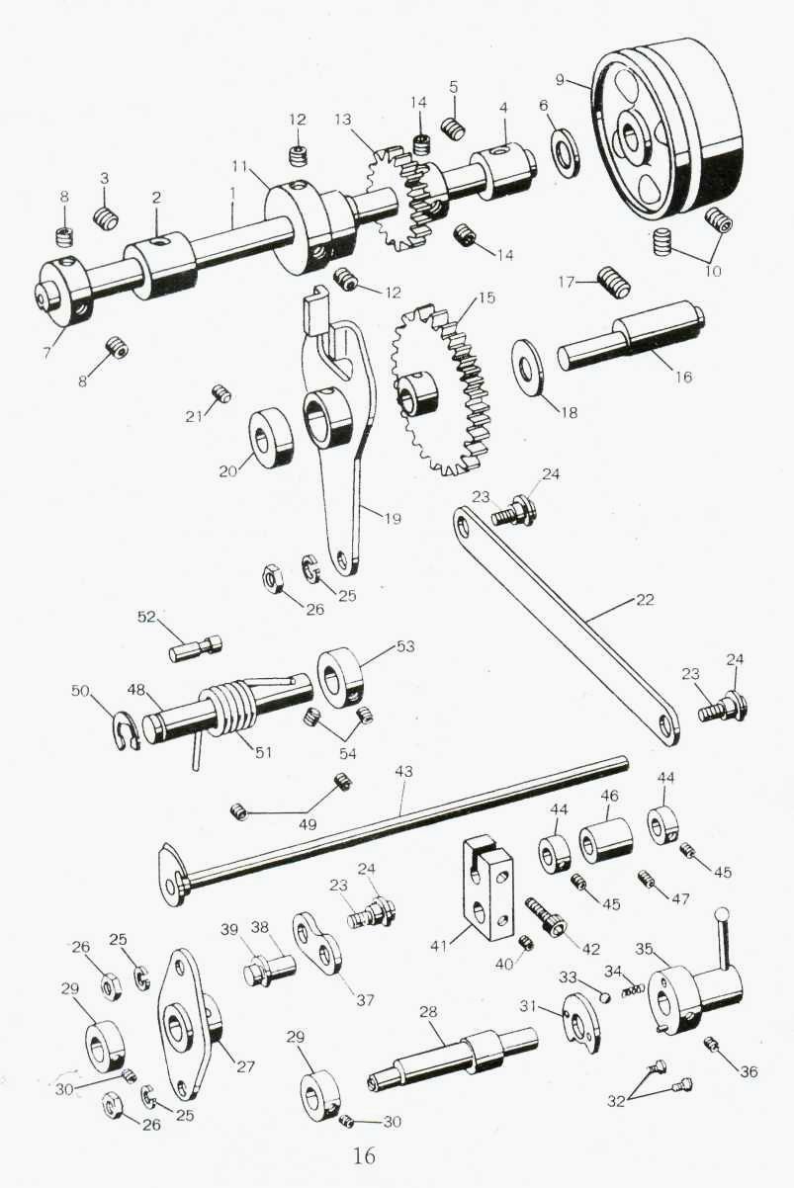

Ref.No. | Part.No. | Description
1 | 80201 | Main shaft
2 | 80204 | Main shaft bushing (Front)
3 | GS37 | Set screw
4 | 80208 | Main shaft bushing (Rear)
5 | GS37 | Set screw
6 | 8201 | Washer
7 | 80203 | Main shaft collar
8 | GS83 | Set screw
9 | 80209 | Pulley
10 | GS55-2 | Set screw
11 | 80206 | Eccentricity bushing
12 | GS9-2 | Set screw
13 | 80207 | Main shaft gear
14 | GS9-2 | Set screw
15 | 80702 | Large gear
16 | 80705 | Gear eccentricity shaft
17 | GS50 | Set screw
18 | 80703 | Washer
19 | 80701 | Gear eccentricity shaft fork
20 | 80704 | Collar
21 | GS50 | Set screw
22 | 80706 | Connecting link
23 | 80708 | Rod holding screw
24 | GB896 | Collar
25 | GB91.7 | Washer
26 | GL8-2 | Hexageon nut
27 | 80709 | Connecting rod
28 | 80711 | Eccentricity shaft
29 | 80704 | Collar
30 | GS50 | Set screw
31 | 80714 | Lever plate
32 | GB819 | Set screw
33 | 8202 | Ball
34 | 20324 | Spring
35 | 80712 | Skip stitch lever
36 | S2 | Set screw
37 | 80720 | Connecting link (Short)
38 | 80707 | Pin
39 | GB896 | Collar
40 | GS43 | Set screw
41 | 80717 | Connecting block
42 | GS55 | Set screw
43 | 80716 | Ridge forming disc shaft assembly
44 | 80718 | Collar
45 | GS83 | Set screw
46 | 80719 | Ridge forming disc shaft bushing
47 | GS29-2 | Set screw
48 | 80817 | Cylinder bed shaft
49 | GS29-2 | Set screw
50 | GB896 | Collar
51 | 80816 | Spring
52 | 80112 | Spring pin
53 | 80818 | Collar
54 | GS83 | Set screw

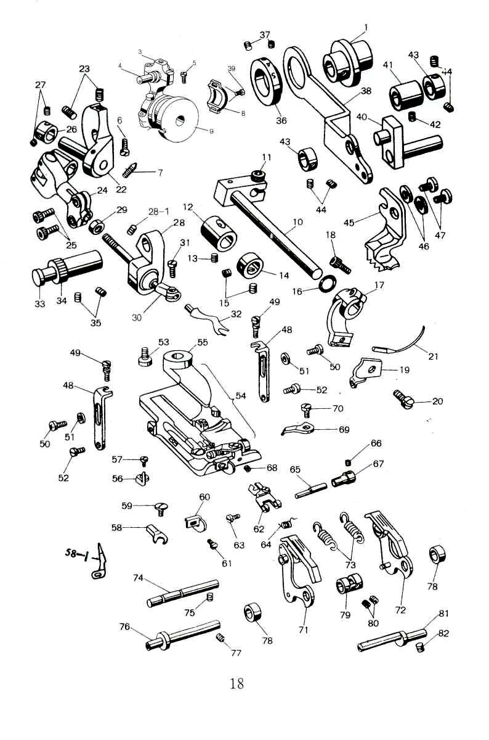

Ref.No. | Part.No. | Description
1 | 80202 | Eccentricity wheel
2 | GS83 | Set screw
3 | 20401 | Needle shaft link
4 | 20404 | Eccentricity ball shaft pin
5 | GS14-2 | Set screw
6 | GS55 | Set screw
7 | GS13-2 | Set screw
8 | 20403 | Cover
9 | 20322 | Ball eccentricity bushing
10 | 80403 | Needle carrier shaft
11 | 80401 | Needle carrier shaft crank
12 | 80402 | Needle carrier shaft bushing
13 | GS45 | Set screw
14 | 80205 | Collar
15 | GS83 | Set screw
16 | GB1235 | "O" ring
17 | 20412 | Needle carrier
18 | 20411 | Set screw
19 | 20415 | Needle clamp
20 | GS16-2 | Set screw
21 | LWx6T | Needle
22 | 20501 | Set screw
23 | GS19-2 | Set screw
24 | 20507 | Universal coupling
25 | GS20-2 | Set screw
26 | 20502 | Orientation ring
27 | GS43 | Set screw
28 | 20514 | Swing arm
28-1 | GS21-2 | Swing arm set screw
29 | GS21-2 | Set screw
30 | 80501 | Thread hook lever

31 | GS23-2 | Set screw
32 | 20516 | Thread hook
33 | 20511 | Swing arm shaft
34 | 80502 | Eccentricity sleeve
35 | GS55-2 | Set screw
36 | 80301 | Stitch regulating eccentricity
37 | GS45 | Set screw
38 | 80302 | Feed lever
39 | GS44 | Set screw
40 | 80305 | Feed lever crank
41 | 80303 | Feed lever crank bushing
42 | GS8 | Set screw
43 | 80304 | Collar
44 | GS47 | Set screw
45 | 20301 | Feed dog
46 | GB861.1 | Washer
47 | GS10-2 | Set screw
48 | 20602 | Presser foot bracket
49 | GS26-2 | Set screw
50 | GS29-2 | Set screw
51 | GB97 | Washer
52 | GS30-2 | Set screw
53 | GS27-2 | Set screw
'-4 | 20600 | Presser foot assembly
55 | 20605 | Plain presser food
56 | 8301 | Chaining finger
57 | GS33-2 | Set screw
58 | 8302 | Needle guide
58-1 | 8303 | Stitch stabilizing guide
59 | GS31-2 | Set screw
60 | 8304 | Edge guide

61 | 8035 | Set screw
62 | 8306 | Cloth retainer
63 | 8307 | Cloth retainer serew
64 | 8308 | Cloth retainer spring
65 | 8309 | Cloth retainer spring eccentric stud
66 | 8310 | Set screw
67 | 8311 | Cloth retainer spring eccentric stud bushing
68 | 8312 | Set screw
69 | 8313 | Cloth vetainer stopper
70 | 8314 | Set screw
71 | 80811 | Feed plate assembly(Left)
72 | 80811 | Feed plate assembly(Right)
73 | 80812 | Spring
74 | 80820 | Spring pin
75 | GS45 | Set screw
76 | 80810 | Feed plate bracket shaft
77 | GS45 | Set screw
78 | 80827 | Collar
79 | 80815 | Collar
80 | GS43 | Set screw
81 | 80814 | Eccentricity shaft
82 | GS45 | Set screw

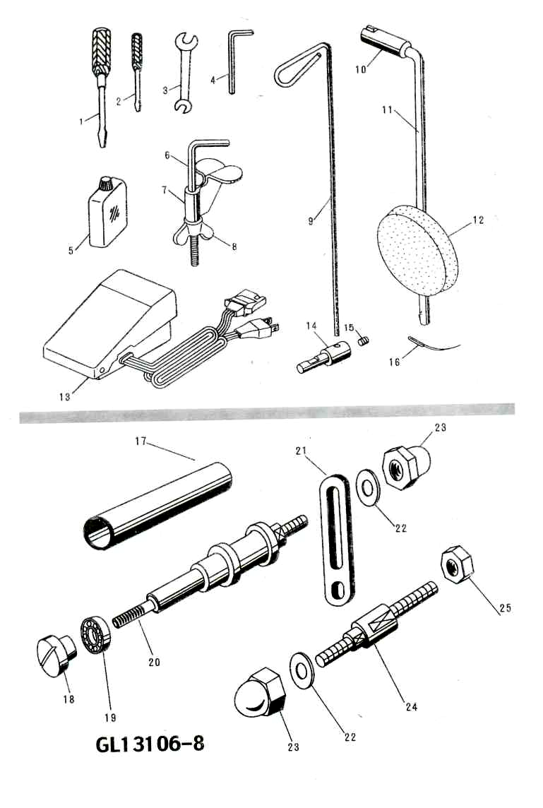

Ref.No. | Part.No. | Description
1 | 8401 | Screw driver(Large)
2 | 8402 | Screw driver(Small)
3 | 8403 | Spanner
4 | 8404 | Wrench
5 | 8405 | Oil
6 | 8406 | Machine clamp shaft
7 | 8407 | Machine clamp
8 | 8408 | Machine clamp nut
9 | 80108 | Thread guide
10 | 80825 | Knee press sleeve
11 | 80826 | Knee press rod
12 | 8409 | Knee press pad assembly
13 | 8410 | Controller pedal
14 | 80106 | Thread guide stud
15 | S40 | Thread guide set screw
16 | LWx6T | Needle
GL13106-8
17 | 8411 | Feed sleeve
18 | GL35-2 | Nut
19 |  | Bearing
20 | 8412 | Small shaft
21 | 8413 | Clamp plate
22 | GB97.1 | Washer
23 | 8414 | Ball nut
24 | 8145 | Clamp shaft
25 | GB6170 | Hexagon nut

